Practical 7

Name:Satishkumar Rajan Nadar

Aim:- Implement MD5

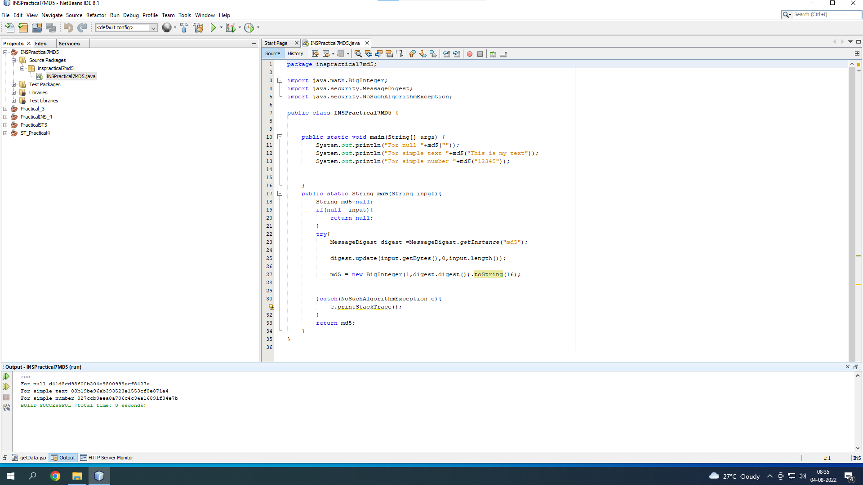

package inspractical7md5;

import java.math.BigInteger;

import java.security.MessageDigest;

import java.security.NoSuchAlgorithmException;

public class INSPractical7MD5 {

public static void main(String[] args) {

System.out.println("For null "+md5(""));

System.out.println("For simple text "+md5("This is my text"));

System.out.println("For simple number "+md5("12345"));

}

public static String md5(String input){

String md5=null;

if(null==input){

return null;

}

try{

MessageDigest digest =MessageDigest.getInstance("md5");

digest.update(input.getBytes(),0,input.length());

md5 = new BigInteger(1,digest.digest()).toString(16);

}catch(NoSuchAlgorithmException e){

e.printStackTrace();

}

return md5;

}

}